**Knox Makers Badge Intro to Solder V1 Kit Instructions**

December 2019

We usually assemble circuit boards starting with the lowest profile components and work our way up to the taller, higher profile components. This board has components on both the front and the back; for ease of assembly we will solder the front components first, the back ones last.

**Start with the resistors**

With this circuit board, like most, we’ll start with the resistors. Resistors are usually labeled on schematics and circuit boards as R1, R2, R3, etc. Resistors are not polarized components so they can be inserted with either end in either hole. They are typically labeled with colored rings. This kit can be built with a wide range of resistor values so use whatever was included in the kit. All of the resistors are of the same value so any resistor can go into any position on the circuit board.

For each resistor bend its leads 90 degrees, insert the resistor from the front and bend the leads outward on the back around 45 degrees to hold it in place. Resistors should sit flush with the circuit board and hold in place when the circuit board is upside down.

You might find it helpful to go ahead and solder the resistors in place and trim the leads on the back flush so they aren’t in the way of the next components.

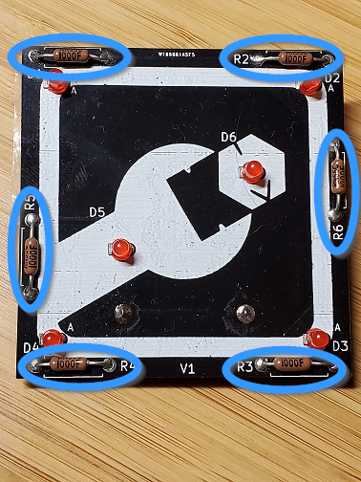

**Now the LEDs**

LEDs are a type of diode and all diodes are polarized with one lead being the anode and one being the cathode. There are two ways to identify which lead is which on an LED. The shorter leg is the cathode, the longer leg the anode. There is also a flat side on the LED housing which indicates that side is the cathode.

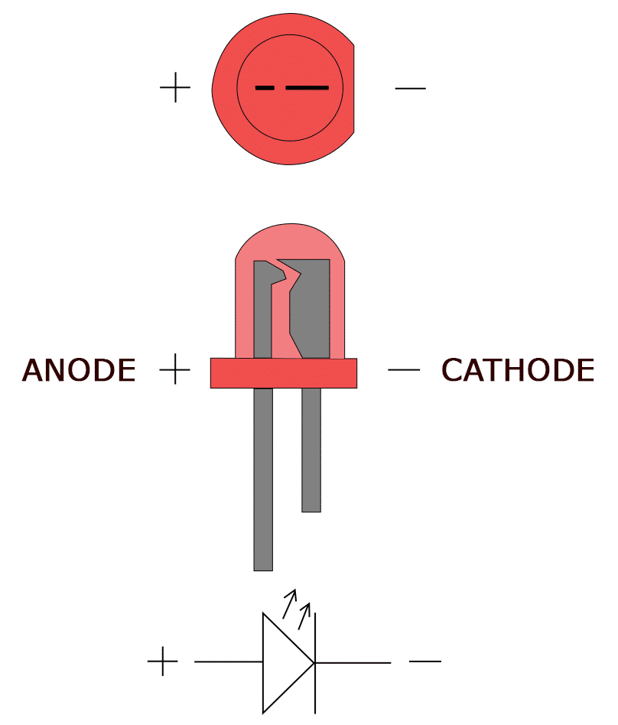

The circuit board has an “A” next to the anode lead on each diode as shown below.

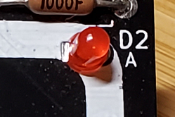

Insert the diodes, carefully noting lead polarity, bend the leads outward on the back, solder them and trim the leads flush.

**The Coin Cell Battery Holder**

The coin cell holder mounts on the back of the circuit board. The circuit board has a black solder mask layer that will cause a small gap between the battery and the square pad it needs to make contact with. You need to build up a very thin mound of solder on that pad. You know there’s enough if you hold the battery against the mound and it just barely rocks back and forth on it. Now you can mount the coin cell holder.

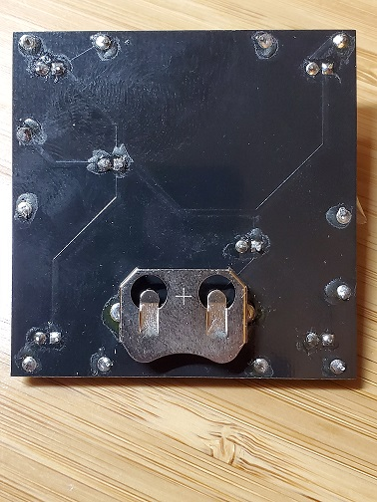

Now insert the battery holder into the back of the board, flip the board over and solder it in place being careful to keep the power jack flush on the back. The power jack has plastic molding inside so try to work quickly as you solder to avoid melting the plastic.

**Test and debug**

Slide the coin cell battery into its holder with the plus side up (making contact with the tabs on the cage). The LEDs should light up and then start blinking.

If no LEDs are lit then check that the coin cell battery is inserted with the plus side up. Also look to see if you’ve got a thin mound of solder on the pad under the coin cell battery so it makes contact with the battery. If those check out then it’s possible that all of the diodes were soldered in backwards. Try to unsolder one, reverse it and see if it lights up, indicating polarity was backwards.

If one or two LEDs aren’t lighting up then they are probably soldered in backwards or possibly there’s a bad LED.

Congratulations, you did it!

**Theory of Operation**

The circuit is simply a coin cell power source and 6 diodes with bias resistors. The coin cell battery provides a 3V power source to the circuit. The LEDs contain internal circuitry that causes them to flash. Each LED has a resistor in series with it to limit the current through the device.

**Bill of Materials**

|  |  |  |
| --- | --- | --- |
| **Qty** | **Designator** | **Item** |
| 1 | - | PCB |
| 1 | J1 | Coin Cell Battery Holder |
| 6 | R1-R6 | Resistors |
| 6 | D1-D6 | 3mm flashing LEDs |

